

Total Knee Replacement (TKR)

Patient information

Introduction

This guide has been written to help you gain a better understanding about what is involved with having a total knee replacement.

On the following pages we cover the reasons and benefits for having the operation, as well as the risks and also what to expect after the procedure. This will hopefully give you some guidance about your stay in hospital and your recovery over the few months following surgery. With the passage of time most people who undergo this operation resume an active life, however it is advisable to avoid very heavy lifting and contact sports in the longer term.

You may find that many of your questions are answered in this booklet, but the nursing staff, physiotherapists and medical staff are always available should any further queries arise.

What is a Total Knee Replacement (TKR)?

The knee joint is the largest and one of the more complex joints in the body. It takes the full weight of the body, whilst allowing bending, straightening and a small degree of rotation.

A total knee replacement is an operation that involves replacing the surface of the damaged knee joint with a specialised metal and plastic implant. The knee joint is made up of three bones – the tibia, the femur and the patella. The ‘main’ knee joint is the articulation between the thigh bone (femur) and the shin bone (tibia). The kneecap (patella) glides up and down a groove on the front of thigh bone (femur) as we bend and straighten the knee. The most common form of damage to the knee joint is the result of degenerative osteoarthritis or ‘wear and tear’. This is the result of thinning and (ultimately) absence of the articular cartilage that covers the end of each bone that makes up the joint. This roughening and distortion of the joint surface causes pain and limitation of movement (stiffness). Knee replacement involves removing any remaining cartilage that is left at the bone ends and replacing this with metal and plastic joint surfaces. These are secured in place by specialised bone cement (metylmethacrylate)

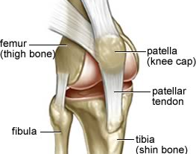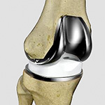

.

The normal knee joint is made stable by the (collateral and cruciate) ligaments. On each side of the knee there are medial and lateral collateral ligaments and within the centre of the knee there is a complex arrangement of the anterior and posterior cruciate ligaments.

There are several different types of artificial knee joints. The choice of knee replacement used will depend on the extent of wear in your joint – specifically whether there has been any loss of bone substance - and whether or not your ligaments have previously been stretched or damaged.

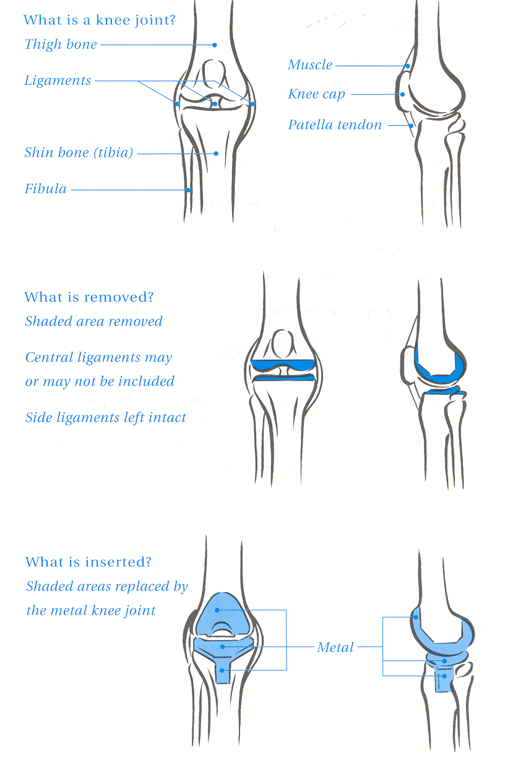

What are the benefits of Total Knee Replacement ?

The operation is classified as major surgery and not to be taken lightly. The ‘new joint’ is primarily recommended for pain relief but it also serves to restore pain free movement, correct deformity and consequently improved mobility.

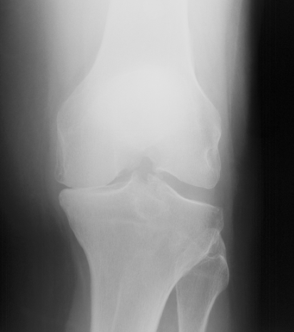

What are the alternatives to Total Knee Replacement ?

The majority of patients who have a total knee replacement will have exhausted all the other treatment modalities before opting for surgery. These include:
- Regular painkillers. Paracetamol and anti-inflammatories such as ibuprofen can help control the pain. Supplements to your diet may also help relieve your symptoms. You should check with your doctor before you take supplements.
- Using a walking stick or wearing an elasticated knee support can support your knee and make walking easier. Regular moderate exercise can help to reduce stiffness in your knee.
- A steroid injection into your knee joint can sometimes reduce pain and stiffness but the duration of relief is often variable and depends on the extent of osteoarthritis present.
- A keyhole operation (arthroscopy) is sometimes offered if you are having mechanical symptoms, (catching, locking or giving out) to clean out the knee joint. This can give some relief but it is usually temporary.
Unfortunately as arthritis tends to deteriorate over time and get worse, all of these measures become less effective, leaving total knee replacement as the last intervention.
How successful is a Total Knee Replacement ?
We tell all our patients that on average 85% of people (17 out of 20) are absolutely delighted with the result of the surgery; their pain is significantly better and their walking is much improved.
About 5% of people (1 in 20) are unlucky and have some kind of complication or side effect secondary to the surgery. As with all operations there are risks involved, some of these complications are small and can be rectified easily, some are more serious and require closer monitoring and further intervention. We will go through these complications and risks in more detail with you during the consent process.
A further 10% of people (2 in 20 are left with something they did not expect from the surgery, although their arthritic bone-on-bone pain has usually gone, This could be an on-going ache, a niggle, a numbness or a stiffness that they were not expecting before they underwent the surgery, and so are not as happy as they thought they would be. The only way we can explain this to patients is that we are not giving you your native knee back, but replacing the damaged knee with specialised metal and plastic implants. The important thing to note in this group of patients is that you may continue to improve up to 18 months to two years after surgery. It is essential to work hard with post-operative exercises and physiotherapy to strengthen things up as best as possible. Having said all this, we can reiterate that the vast majority of patients are delighted with this surgery which is successful and really helps improve their quality of life.

What happens in hospital?

The day of admission

Most patients are admitted on the day of surgery and will be seen by the anaesthetist to discuss the different types of anaesthetic involved and by their surgeon to answer any final questions, go through the consent process and mark the correct leg.

Risks and potential complications of Total Knee Replacement

Common (2-5%)
- Pain
Some slight discomfort is to be expected following every type of surgery. You will be given medication to control the pain - post operatively and on discharge.
- Bleeding
This can happen during or after surgery and there is a possibility (rare) that this may require a blood transfusion.
- Blood clots (Deep Vein Thrombosis)
These usually occur in the legs (DVT) and can occasionally move through the blood stream to the lungs (pulmonary embolus) making it difficult to breath. A pulmonary embolism may be fatal (3 in 1000 cases). The risk of forming such clots is greater after any surgery especially lower limb surgery. You will be given treatment to reduce the risk of blood clots forming. Starting to walk and moving early is one of the best ways to prevent blood clots from forming.
- Knee stiffness
Stiffness may be a problem especially if the movements were significantly restricted pre operatively. Manipulation (under anaesthetic) may be necessary.
- Difficulty passing urine (males especially)
If this persists you may be given a catheter until you are more mobile.

Less common (1-2%)
- Infection in the surgical wound
You will be given a large dose of antibiotics just before your surgery and the procedure is performed in a clean environment (theatre) with sterile equipment. Despite this infections still occur. The wound may become red, hot and painful (infected). This usually settles with antibiotics but may require an operation to wash out the joint if there are concerns that the metalwork is involved (deep infection). Very occasionally the metalwork may need to be removed and replaced at a later stage.

Rare (<1%)
- Damage to the nerves around the knee
Efforts are made to avoid this. However damage to the small skin nerves can result in some temporary or permanent alteration of sensation to the skin on the front of the knee. Rarely the larger nerves around the knee can be involved and this can result in temporary or permanent weakness and/or altered sensation in the lower leg or foot.
- Prosthesis wear and loosening
Modern techniques and implants mean about 80% of knee replacements will last over 15 years. If early loosening does occur this most likely will require further surgery.
- Damage to the blood vessels behind the knee
This can lead to loss of circulation to the leg and foot. If this happens you will need immediate surgery to restore the blood flow and could (very rarely) result in amputation.
  - Altered wound healing
Most wounds heal well but the wound may become red, thickened and painful (keloid) especially in the Afro-Caribbean race.

The operation takes between 1-2 hrs but afterwards patients spend some time in recovery (an area in theatre where monitoring of blood pressure and breathing takes place) before you return to the ward.

After surgery

Exercises
Once back on the ward you will be encouraged to move around as much as comfort allows. You should move your feet and ankles, and your operated knee within the limits of the bandaging. Apart from moving your operated leg you should also try and move around in bed to avoid pressure areas on your bottom and heels, and also practice deep breathing exercises to encourage good lung function.

Eating and Drinking
Following your operation you may feel sick, a common symptom following surgery and a side effect of pain-relieving drugs. Once you are able to tolerate fluids you will be started on a light diet, increasing to a full diet within 48 –72 hours. If nausea is a continuing problem, there is medication available which can minimise it in most circumstances.

Wound

At the end of your operation the incision over the front of your knee will be closed either with stitches, clips or glue. The dressing we apply in theatre is left in place unless there is major bleeding and soiling of the dressing. This minimises the risk of contamination and subsequent wound infection. Stitches or clips will need to be removed 10-14 days after your operation. These can be removed at your local surgery and the nursing staff will organise this for you before you are discharged.
You will be able to shower whilst the stitches or clips are still in situ.

Pain relief

Pain relief after your operation can be kept to acceptable levels by a variety of medications and techniques. Your anaesthetist who will have chosen the most suitable pain relief medication for your needs will have prescribed these. Your pain level may be acceptable while resting, but may increase when you move. Therefore it may be advisable to ask for a “top-up” 10 to 15 minutes before physiotherapy treatment.

Ice packs and / or cooling bandages placed on the knee are also beneficial for pain relief and swelling. Your physiotherapist or nurse can help you with this.

Swelling

It is normal to expect swelling and bruising of your knee and leg and foot following this surgery. This can take six weeks or more to resolve. However if you notice a sudden increase in the swelling with pain and redness of the skin please contact the hospital or your G.P.

Physiotherapy
Normally patients who have had a knee replacement are independently mobile, getting in and out of chairs, getting in and out of bed and walking around the ward within a few days. The physiotherapists will help you get up and mobile from day 1, and undertake the exercises needed.

On discharge from hospital

On discharge a letter will be sent by the hospital to your GP which summarises what operation and treatment you have received, but this often takes a few days before it arrives. Your wound will be covered by a dressing and underneath the metal clips will need to be removed by your GP or district nurse in 10/12 days. You will be reviewed by your surgeon in the outpatient clinic at 6 weeks. The average hospital stay for a knee replacement patient is 3 to 4 days, but it can vary between individuals.

How mobile will I be after discharge?

Before you are allowed to leave the hospital you should be independently mobile with your crutches and be safe walking up and down stairs. You will still be encouraged to put as much weight through your operated leg as possible.

Although you will be encouraged to get outdoors for short periods, for most of the first six weeks you will be indoors and should travel outdoors preferably with a friend or family member.

When can I drive?

Normally patients are advised to refrain from driving for at least six weeks, i.e. until the first clinic review. After that time, once you are able to walk without crutches you are safe enough to drive but this would normally involve short journeys for the first couple of weeks, before progressing to normal driving. If the operated leg is your right knee it is often harder to recover sufficiently to allow safe operation of the brake and it could be 9 or 10 weeks before you are safe to drive. As a general rule, once you are able to walk without crutches or sticks without a limp, you are able to drive.

When can I return to work?

Most patients will be off work for around three months. If your work is sedentary or supervisory you can return to work in a part time capacity or on light duties from six weeks post surgery, but this would only be if you have a degree of control over your working environment. Normally return to work will be discussed more formally at the six week clinic visit.

What medication will I need following discharge?

You will be given the medication which you brought into hospital and if you are on medication for other medical conditions such as diabetes, asthma, blood pressure treatments, etc. these should be continued on leaving hospital. Specifically with regard to the knee operation you may require a few weeks supply of analgesics such as paracetamol or anti inflammatories such as ibuprofen and this will be given by the hospital. You will also be given a tablet (Rivaroxaban) for 10 days post operatively which thins the blood and reduces the risk of developing deep vein thrombosis (DVT).

What exercise should I do?

Prior to discharge from hospital you will have been seen by the physiotherapists and given an exercise programme to follow. This is important first of all to get your knee working properly following the operation and secondly to help recover any muscle loss which has occurred as a result of the prolonged wear and tear process which led to the necessity for a knee replacement. Usually the physiotherapist will arrange for you to be reviewed either by the physiotherapists at the hospital or a more local physiotherapy unit. On average this would be once per week during the first few weeks following discharge from hospital. This will allow the physiotherapists to monitor progress and give further advice and encouragement as required. The amount of physiotherapy will be dependent on individual circumstances.

Long term care

Health and general fitness are important. We would advise that you try to keep your weight down, thereby reducing the stress on the knee joint.

The risk of infection after your knee replacement is very low. However as a precaution:

- Notify your G.P. if you get any kind of infection, so that you can receive antibiotics as soon as possible.

- Inform your dentist of your joint replacement. As a precaution he/she may prescribe antibiotics, particularly for tooth abscesses.

For more general information regarding total knee replacement you can visit this website: www.orthoinfo.aaos.org/topic.cfm?topic=A00389

Physiotherapy after your Total Knee Replacement

- It is important to keep the circulation moving in your operated leg. Moving the foot up and down at the ankle will assist the circulation.
- Your physiotherapist will start your exercises to regain the strength of your muscles around the knee the day after your operation.
- Depending on your surgeons instructions you should be able to get out of bed and start mobilising on the first day after your operation, under the direction of your physiotherapist. Initially you will be given a walking frame to use and you will progress to sticks or crutches as you are able.
- Exercises to strengthen the muscles at the front of the knee (the quadriceps) and the muscles at the back of the knee (the hamstrings) should be practised 3-4 times a day progressing to hourly as you improve. These exercises can be found at the back of this leaflet.
- At approximately 6 days after your operation, if your knee is bending well and you are able to lift your leg off the bed with your knee straight (“straight leg raise”) you will be discharged from hospital. You will be walking with sticks or crutches and will be able to go up and down stairs safely.
- Attendance at an outpatient physiotherapy department may continue until your knee has regained full movement, and the muscles are strong enough to support the knee without the use of sticks. Your physiotherapist will discuss outpatient physiotherapy with you.

